**1. Health Savings Accounts (HSAs)**

**2. Personal Loans**

**(Presented By Alan Stuart K)**

**1. Health Savings Accounts (HSAs):**

**Introduction:**

Health Savings Accounts (HSAs) are specialized, tax-advantaged savings accounts designed to help individuals and families save for medical expenses. They are exclusively available to those enrolled in high-deductible health plans (HDHPs), which typically have lower premiums but higher out-of-pocket costs. Contributions to an HSA can be made by the account holder, their employer, or any third party, and these contributions are tax-deductible, reducing the individual's taxable income.

**Insights:**

* **Growth:** HSAs have seen steady growth in both the number of accounts and total assets over recent years, indicating increasing adoption and reliance on these accounts for healthcare savings.
* **Tax Benefits:** Contributions, earnings, and withdrawals for qualified expenses are tax-advantaged, making HSAs a powerful tool for managing healthcare costs and reducing taxable income.
* **Investment Options:** Many HSAs offer investment options, allowing account holders to grow their savings over time, similar to retirement accounts.

**Use Cases:**

1. **Medical Expense Savings:** Individuals use HSAs to save for routine medical expenses, such as doctor's visits, prescription medications, and medical supplies.
2. **Emergency Medical Funds:** HSAs can serve as a safety net for unexpected medical emergencies, reducing the financial burden of high out-of-pocket costs.
3. **Long-term Healthcare Planning:** HSAs can be used to save for future healthcare needs, including long-term care and retirement healthcare expenses.
4. **Tax Reduction:** High-income earners use HSAs to lower their taxable income while simultaneously saving for healthcare expenses.

**Applications:**

* **Individuals and Families:** HSAs are particularly beneficial for individuals and families with high-deductible health plans who want to save for both immediate and future medical expenses.
* **Employers:** Many employers offer HSAs as part of their benefits packages, often contributing to employees' accounts as an incentive to enrol in HDHPs.
* **Financial Advisors:** Advisors recommend HSAs to clients looking for tax-advantaged savings options and those planning for healthcare expenses in retirement.

**Data:**

| **Metric** | **Value** |
| --- | --- |
| **2024 Individual Contribution Limit** | **$4,150** |
| **2024 Family Contribution Limit** | **$8,300** |
| **Average Balance (2023)** | **$3,980** |
| **Total Assets (2023)** | **$98.5 billion** |
| **Annual Growth Rate** | **~7%** |
| **Average Interest Rate (savings)** | **0.1-1%** |
| **Average Return (investments)** | **5-7%** |
| **Percentage of Americans Eligible** | **~30%** |
| **Percentage Investing HSA Funds** | **~7%** |

**2. Personal Loans:**

**Introduction:**

Personal loans are unsecured loans offered by banks, credit unions, and online lenders, providing individuals with a flexible and accessible source of financing for a variety of personal needs. Unlike secured loans, such as mortgages or auto loans, personal loans do not require collateral, which means the borrower does not have to pledge any assets to secure the loan. This lack of collateral typically results in higher interest rates compared to secured loans, but personal loans still offer competitive rates, especially for borrowers with good credit.

**Insights:**

* **Flexibility:** Personal loans offer flexibility in terms of loan amount and repayment terms, making them suitable for a wide range of financial needs.
* **Interest Rates:** Interest rates on personal loans can vary widely based on the borrower’s credit score, income, and the lender's policies.
* **Debt Consolidation:** One of the most common uses of personal loans is to consolidate higher-interest debt into a single, lower-interest payment.

**Use Cases:**

1. **Debt Consolidation:** Borrowers use personal loans to consolidate multiple high-interest debts, such as credit card balances, into one loan with a lower interest rate.
2. **Home Improvement:** Personal loans are a popular option for financing home improvement projects, providing the funds needed for renovations or repairs.
3. **Major Purchases:** Personal loans can be used to finance significant purchases, such as appliances, furniture, or electronics, when immediate funds are not available.
4. **Unexpected Expenses:** In cases of emergency or unexpected expenses (e.g., medical bills, car repairs), personal loans offer quick access to funds.

**Applications:**

* **Individuals:** Personal loans are useful for individuals needing quick access to cash for various purposes, from managing debt to funding personal projects.
* **Financial Planning:** Financial planners may advise clients to consider personal loans for managing high-interest debt or financing significant expenses without depleting savings.
* **Lenders:** Banks and other financial institutions offer personal loans as part of their lending products, often targeting customers looking for debt consolidation options or financial flexibility.

**Data:**

| **Metric** | **Value** |
| --- | --- |
| **Average Loan Amount (2023)** | **$17,200** |
| **Average Interest Rate (2023)** | **11.48%** |
| **Total Outstanding Debt (2023)** | **$210 billion** |
| **Average Loan Term** | **55 months** |
| **Percentage of Adults with Personal Loans** | **~19%** |
| **Average Credit Score for Approval** | **680** |
| **Most Common Use** | **Debt consolidation** |
| **Annual Growth Rate in Originations** | **~5%** |
| **Average Origination Fee** | **3-8%** |

**Graphs:**

**Graph 1:** HSA Asset Growth by Bank:

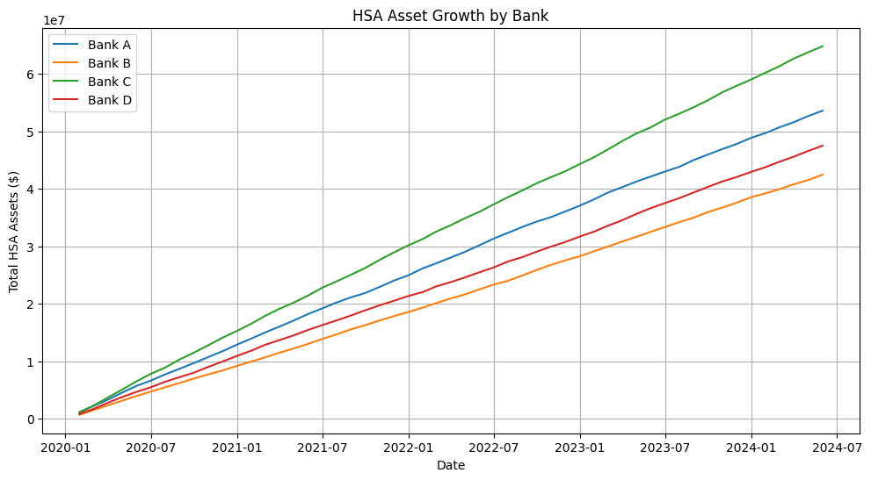

**Inference:**

* The growth trends can reveal which banks are most successful in attracting HSA deposits.
* Steeper growth curves might indicate more aggressive marketing strategies or better HSA offerings.
* Seasonal patterns could suggest when people tend to contribute more to their HSAs (e.g., during open enrolment periods).
* Any sudden changes in growth rates might correspond to policy changes or economic events affecting HSA contributions.

**Graph 2:** HSA Market Share as of 31/05/24:

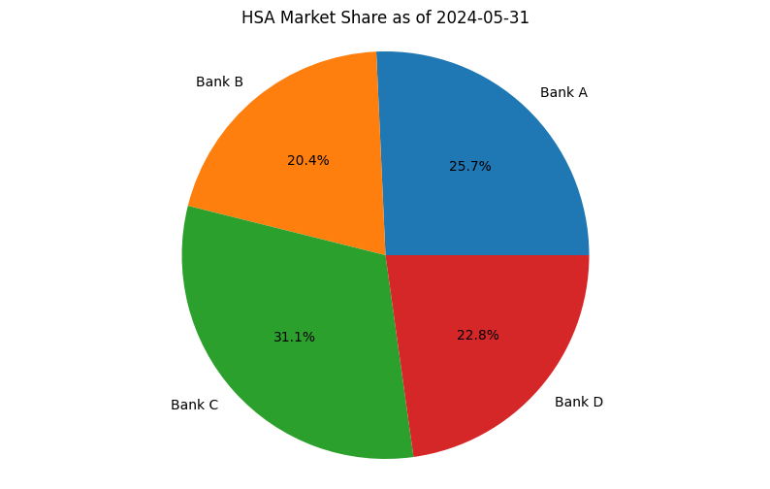**Inference:**

* Changes in market share can indicate shifts in competitive positioning among banks.
* A bank increasing its market share might be offering more attractive HSA features or better investment options.
* Stable market shares could suggest a mature, settled market with established customer loyalties.
* Any significant redistribution of market share might indicate disruptive innovations or marketing strategies in the HSA space.

**Graph 3:** Personal Loan Interest Rates:

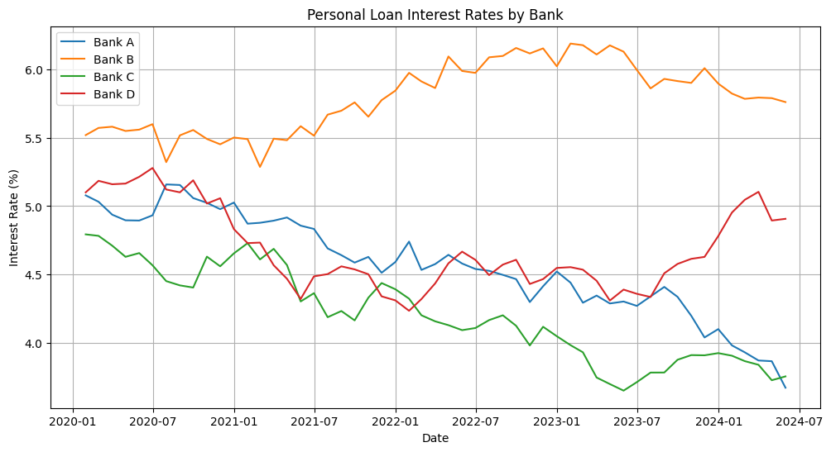**Inference:**

* The overall trend can indicate the general direction of the lending market (becoming more or less expensive for borrowers).
* Differences between banks' rates can reveal varying risk assessments or target customer segments.
* Sudden changes might correspond to shifts in monetary policy or significant economic events.
* The spread between the highest and lowest rates could indicate the level of competition in the personal loan market.

**Graph 4:** CurrentPersonal Loan Rates as of 31/05/24:

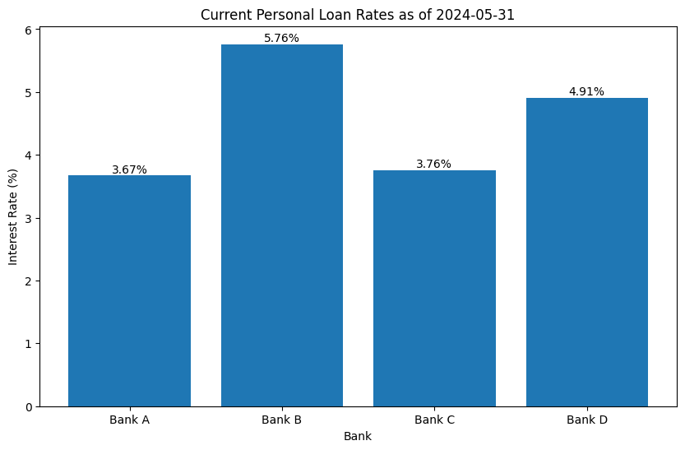**Inference:**

* If showing rate spreads, it could reveal how the range of available rates has changed over time, indicating market competitiveness.
* If displaying correlations, it might show how closely different banks' rates move together, suggesting the influence of common market factors versus bank-specific strategies.
* Any outliers or divergent trends could highlight banks with unique lending strategies or risk assessments.

**Graph 5:** 3-Month Rolling Average HSA Asset Growth Rate by Bank:

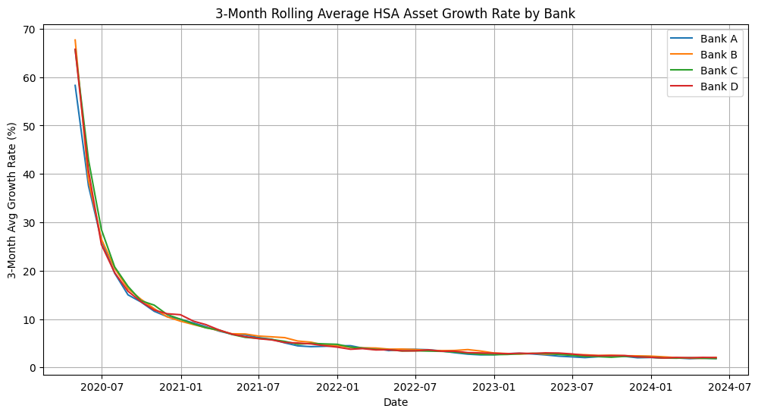**Inference:**

* All banks show fluctuating growth rates, indicating a dynamic HSA market.
* Bank C consistently demonstrates the highest growth rate, suggesting it might have more aggressive HSA marketing strategies or better incentives for customers.
* Bank B shows the most volatile growth rate, which could indicate less stable HSA policies or customer base.
* There's a general trend of converging growth rates towards the end, possibly due to market saturation or increased competition.

**Graph 6:** Personal Loan Rate Spread (Highest - Lowest):

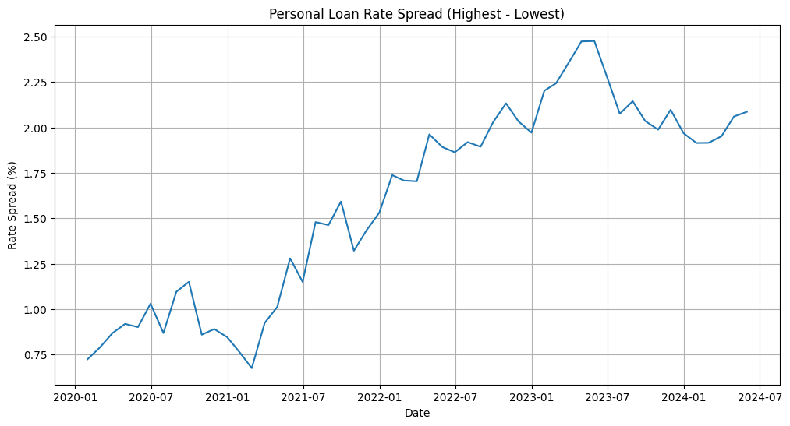**Inference:**

* The rate spread has been gradually increasing, indicating growing disparity in loan pricing strategies among banks.
* Larger spreads suggest more opportunities for consumers to shop around for better rates.
* The increasing spread might also indicate growing risk differentiation or market segmentation among banks.
* Periodic spikes in the spread could correspond to significant economic events or policy changes affecting the lending market.

**Graph 7:** HSA Market Share Over Time (Stacked Area Chart):

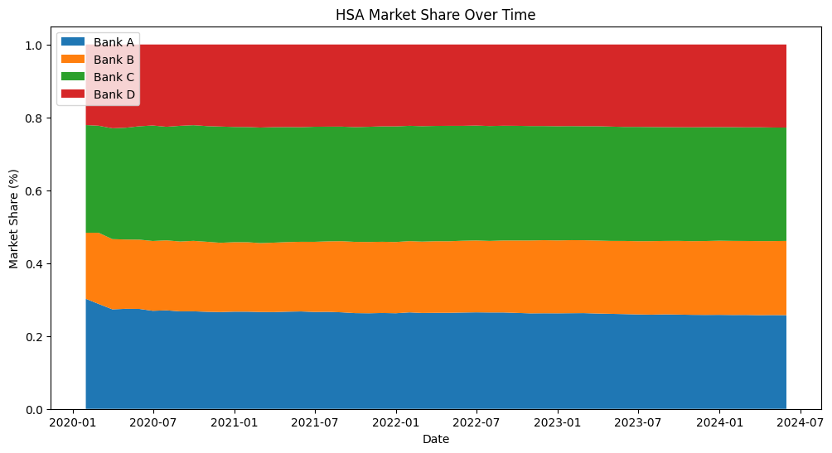**Inference:**

* Bank C has consistently held the largest market share, aligning with its high growth rate observed earlier.
* Bank B's market share has been gradually decreasing, which could explain its volatile growth rates.
* Banks A and D have maintained relatively stable market shares, suggesting consistent HSA strategies.
* The overall market structure hasn't dramatically changed, indicating a mature and stable HSA market.

**Graph 8:** Correlation of Personal Loan Rates Between Banks:

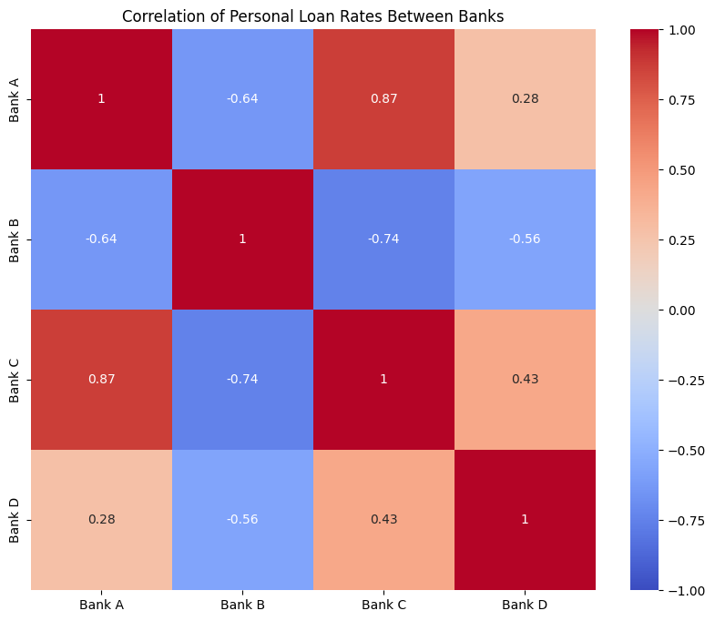**Inference:**

* There's a strong positive correlation among all banks, suggesting that they generally move their rates in the same direction.
* Bank A and Bank C show the strongest correlation, possibly indicating similar risk assessment models or target customer bases.
* Bank B shows the weakest correlations with others, hinting at a more independent rate-setting strategy.
* The high correlations overall suggest that external factors (like federal interest rates) strongly influence all banks' loan rates.

### Conclusion:

Health Savings Accounts (HSAs) and personal loans are two financial tools that serve distinct yet complementary purposes in managing personal finances. HSAs offer a tax-advantaged way to save for current and future medical expenses, making them a vital resource for individuals with high-deductible health plans. Their unique triple tax benefit—tax-deductible contributions, tax-free growth, and tax-free withdrawals for qualified medical expenses—makes them an efficient vehicle for healthcare savings and long-term financial planning. On the other hand, personal loans provide flexible, unsecured financing options for a wide range of needs, from debt consolidation to unexpected expenses. With fixed interest rates and repayment terms, personal loans offer predictability and convenience, especially useful in managing large purchases or emergencies without needing to pledge collateral. Together, HSAs and personal loans represent critical elements in a comprehensive financial strategy, addressing both the need for planned healthcare savings and the flexibility to manage immediate financial needs. Whether optimizing for tax benefits and long-term savings through HSAs or securing necessary funds through personal loans, these tools help individuals navigate their financial landscapes with greater confidence and security.